Job Offer Tool (JOT)

UCGIS Tools User guides

**Table of Content**

Tools Login & Registration 3

forgot your password 3

create a new account 4

User details and organizations 4

join an organization 5

leave organization 5

create an organization 6

delete your organization 6

create or delete divisions 6

remove users 6

add users 6

Home page 7

share a JO 8

duplicate a JO 8

edit an existing JO 8

create a new (blank) JO 8

default search 8

advanced search 8

search by BoK concept 9

Job offer detail view 9

Create or Edit a Job offer 10

New Job offer 10

creating a new job offer based in existing occupational profile(s) 10

add required knowledge 11

add required skills 11

find BoK concepts 11

add a concept selected and their related skills 12

remove a knowledge or a skill 12

add a custom skill 13

add transversal skills 14

add Datasets required 14

add Tools required 14

add languages 15

add further job offer details 15

add contact details 15

request for a Motivation letter 15

add the type of contract 15

Glossary of terms 16

## 

**About**

The [Job Offer Tool](http://ucgis-tools-jot.web.app/) (JOT) allows users to create job offers in the field of Earth Observation and Geographic Information. These job offers can be based on an existing occupational profile, previously created in the [Occupational Profile Tool](http://ucgis-tools-opt.web.app/) (OPT), or created from scratch. Job offers are linked to the EO4GEO Body of Knowledge (BoK) for EO/GI-specific concepts and skills, and to the [European Skills/Competences and Occupation (ESCO) classification](https://ec.europa.eu/esco/portal/skill) for transversal skills.

The Job Offer Tool (JOT) is part of the EO4GEO tool suite, and was developed by the [Geospatial Technologies Research Group](http://geotec.uji.es/) (GEOTEC) from the Universitat Jaume I, Castelló de la Plana, Spain.

## Tools Login & Registration

The JOT has two types of users: anonymous and registered users. An anonymous user directly sees public Job Offers, without being logged in (See Home page section). A registered user needs to log in and hereby gains access to additional functionalities.

Figure 1 shows the login page from all UCGIS Bok-related tools, including OPT. If you have an account, type in your email (1), your password (2) and click button ‘Login’ (3).

If you

forgot your password

, type in your email (1) and click ‘Forgot password?’ (4). You will receive an email to recover your password. If you don’t have an account, click Register Now! (5) and proceed to Figure 2 Registration form. You can also sign in with your Google account (6).

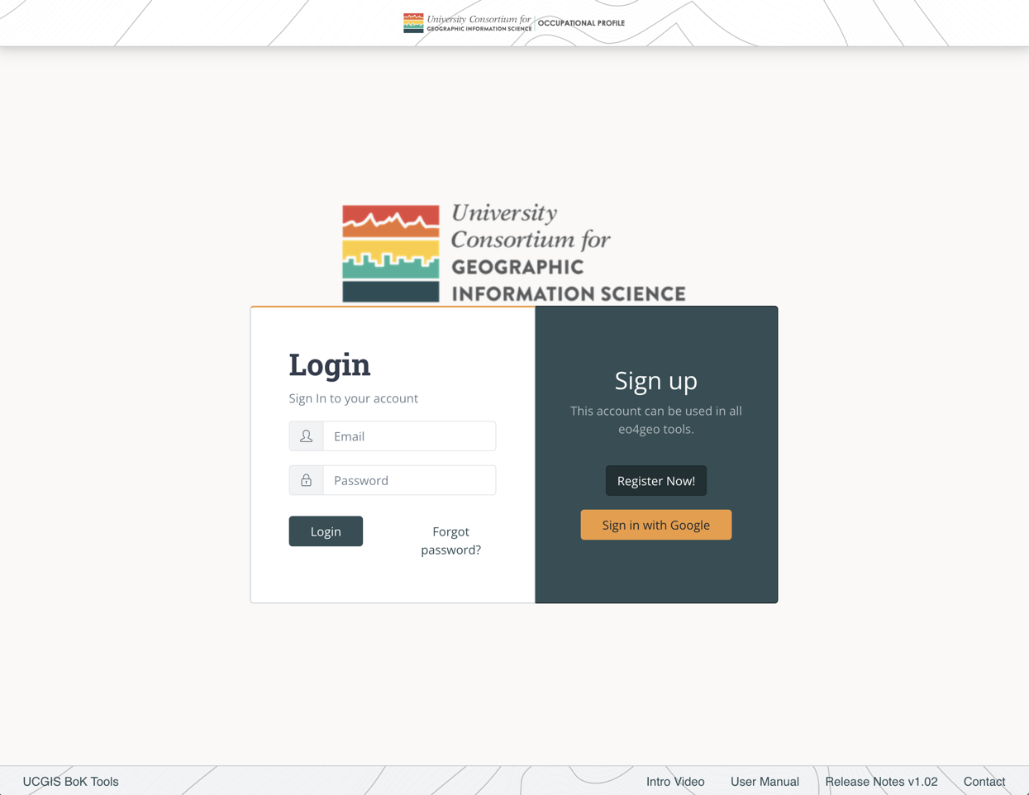

1

2

3

4

5

6

Figure 1. UCGIS Tools login page

To

create a new account

, fill in your email (1), your password (2) and repeat your password (3). The password you chose should contain at least 6 characters. (Figure 2).

Then click the ‘Register’ button (4) and you will be immediately redirected to the Home page.3

Figure 2. Registration form

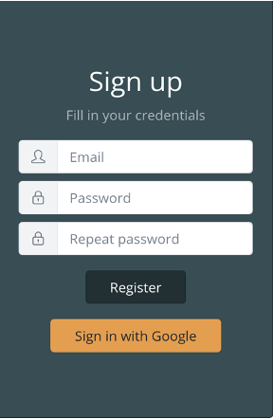

1

2

3

4

When registering, if you see the error ‘The email address is already in use by another account’, it means your email is already registered. Write your email in the login part of the form and click ‘Forgot password?’ to receive a link with instructions to recover it.

## User details and organizations

After logging in, the user will be able to see his/her email address in the top navigation bar (Figure 3).



1

2

3

4

Figure 3. Navigation bar

Clicking in the email address (1) the user will be able to save his / her name and recover the password.

Clicking on the ‘Your organization’ (2) link displays every organization the user belongs to. These organizations are important in order to make collaborative edits of the content created in the tool, as users belonging to the same organizations are able to edit content from within these organizations. Also, private content within an organization is not shown to anonymous or external users, but users belonging to the same organization can see it.

To create new content the user needs to belong to at least one organization.

The ‘Home’ button (3) goes to the list page.

The ‘Log Out’ button (4) logs out the user and brings them to the login page.

To

join an organization

, click on the ‘Your organization’ button (2). In the organizations page (Figure 4) click on the dropdown to search for the desired organization. You can type to filter by text. Once you find the desired organization, select it and click Join button (2).

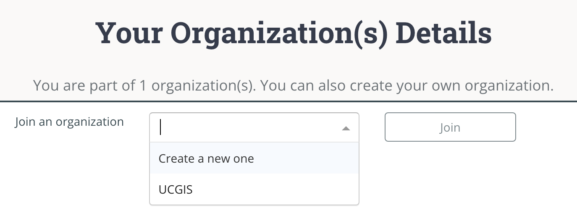

2

1

Figure 4. Dropdown in organizations page

You will be automatically added to that organization as a regular user. You can click on the

leave organization

button to be removed from it (1) (Figure 5).

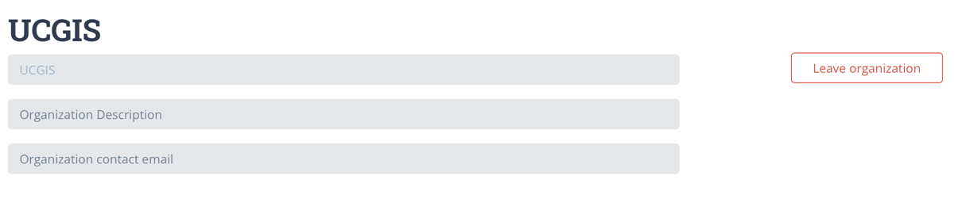

1

Figure 5. A regular user being member of an organization

If you want to

create an organization

select the ‘Create a new one’ option and click on the ‘Join’ button (1) (Figure 6). After that, you can fill in your organization name and description (2) and save changes (3) or you can

delete your organization

(4).

To help in organizing the content inside your organization you can create ‘Divisions’ under an organization. As you are the creator of the organization, that makes you ‘Admin’. As an Admin, you can

create or delete divisions

, by typing the name and ‘Add division’ button (5). They are not compulsory to be able to create content but divisions will help in organizing the content inside your organization.

You can change a user role (Admin / Regular) inside your organization by clicking the button group (6). An admin can also

remove users

(7) of an organization.

Finally, you can

add users

to your organization by typing the email address they used to log in. After your organization is created, new users can also join themselves.

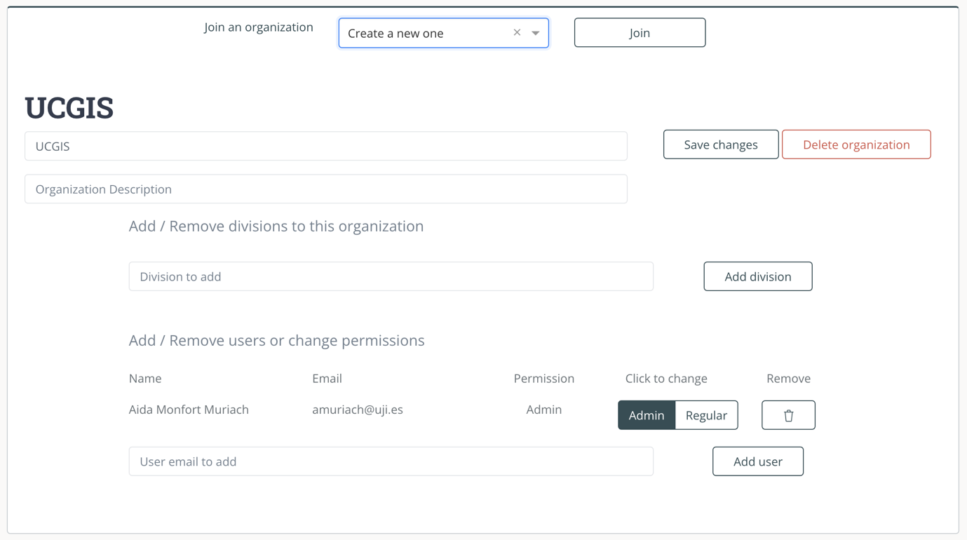

7

6

8

5

4

3

2

1

Figure 6. Organization administration

## Home page

Figure 3 shows JOT’s home page with a list of job offers (1). Each job offer contains: its name, how many BoK-related concepts the offer is annotated with (Knowledge), how many transversal skills it has, its last update and its description. All job offers (JO) marked as public are shown. If the user is logged in and belongs to an organization who has created job offers, these will also appear in the list, the name of the organization appears in orange next to the title.

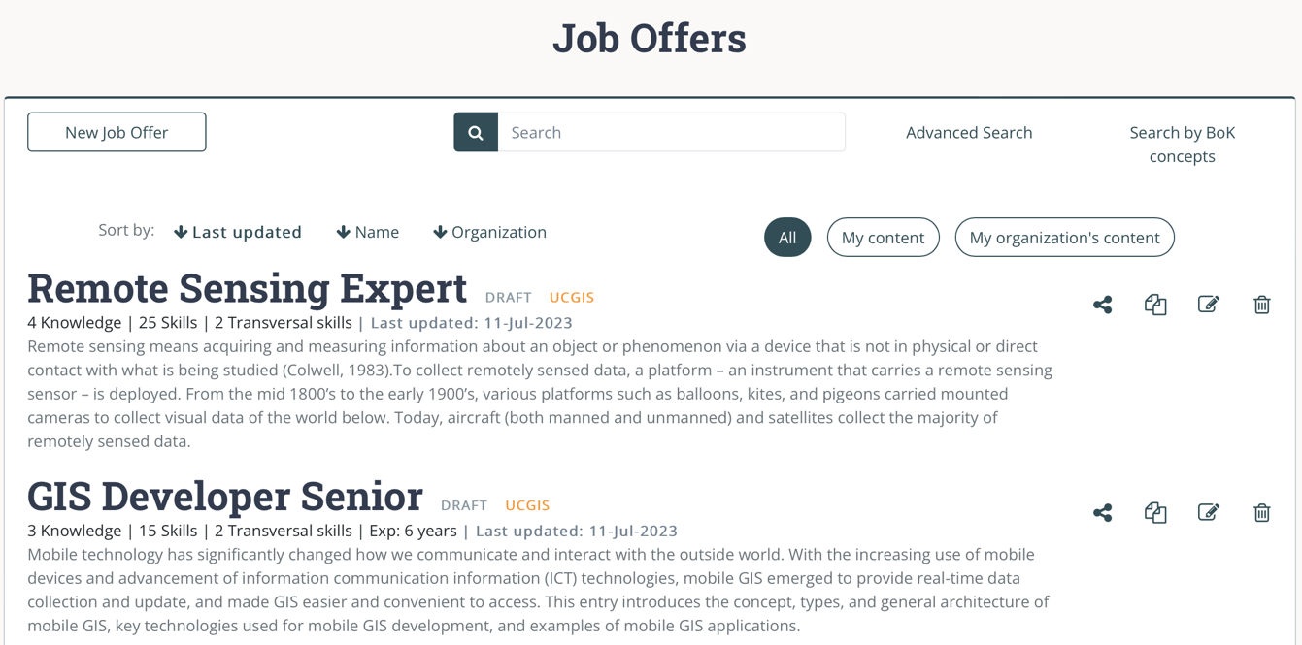

4

3

2

1

Figure 7. Home page view

Each JO has a toolbox menu (2), in which the user can find the following options from left to right: share, duplicate, edit and delete (Figure 4). Some actions may be disabled depending on the type of user (anonymous or logged in), see Figure 4.

Figure 8. Toolbox with all actions enabled

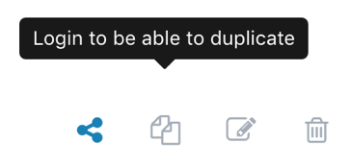

Figure 9. Toolbox with some actions disabled as in the anonymous view

To

share a JO

, click the ‘Share’ option and select one of the alternatives (from left to right) ‘copy link’, ‘export to pdf’ or ‘export to xml’ format (Figure 5).

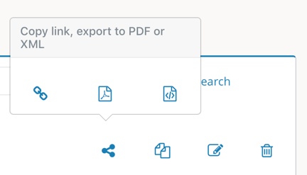

Figure 10. Options to share a JO

To

duplicate a JO

, the ‘Duplicate’ Option creates a new JO which is prefilled with all information from the originating OP. You can then edit this information, rename the JO and save it as a different job offer. This new JO is owned by you, so you can later make modifications to it.

To

edit an existing JO

, the ‘Edit’ Option allows the user to modify those JOs he/she previously created. Finally, the ‘Delete’ Option removes a JO. JOs created by other users outside your organizations cannot be edited nor deleted.

To

create a new (blank) JO

, click the ‘New Job offer’ button (3).

Job offers can be filtered by typing in the search box (4). The

default search

looks for the text typed in title and description.

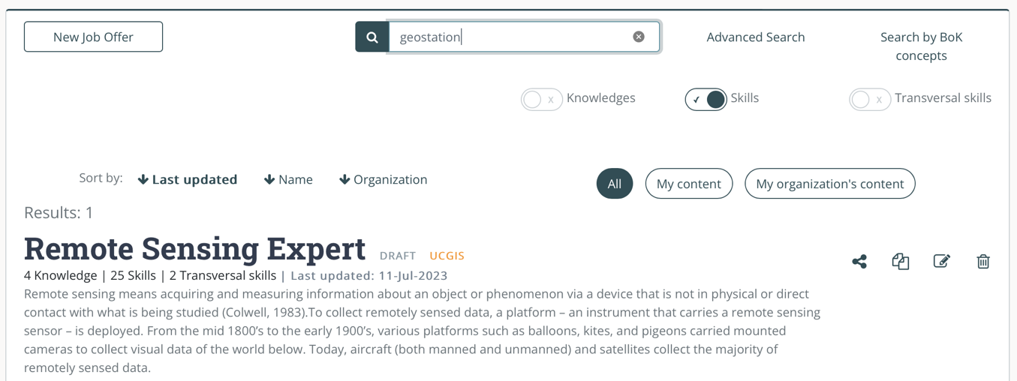

5

4

3

2

1

Figure 11. Advanced search

If you also need to search in knowledge (1) and/or skills (2) and/or transversal skills (3) click the ‘

advanced search

’ button (4) (Figure 6). Then, enable the Options you want to search in by clicking on each slider and type in your search. Job offers will be filtered according to your defined search criteria.

If you want to explore the BoK and then select one or more concepts to be filtered by click the ‘

search by BoK concept

’ button (4) (Figure 6) and the BoK Visualiser and Search component will open. From there the BoK can be explored and searched, when you find the required concept, select it and continue searching or click on ‘Finish’ to show the filtered results.

## Job offer detail view

The user can enter into a Job offer by clicking in its name (Figure 12).

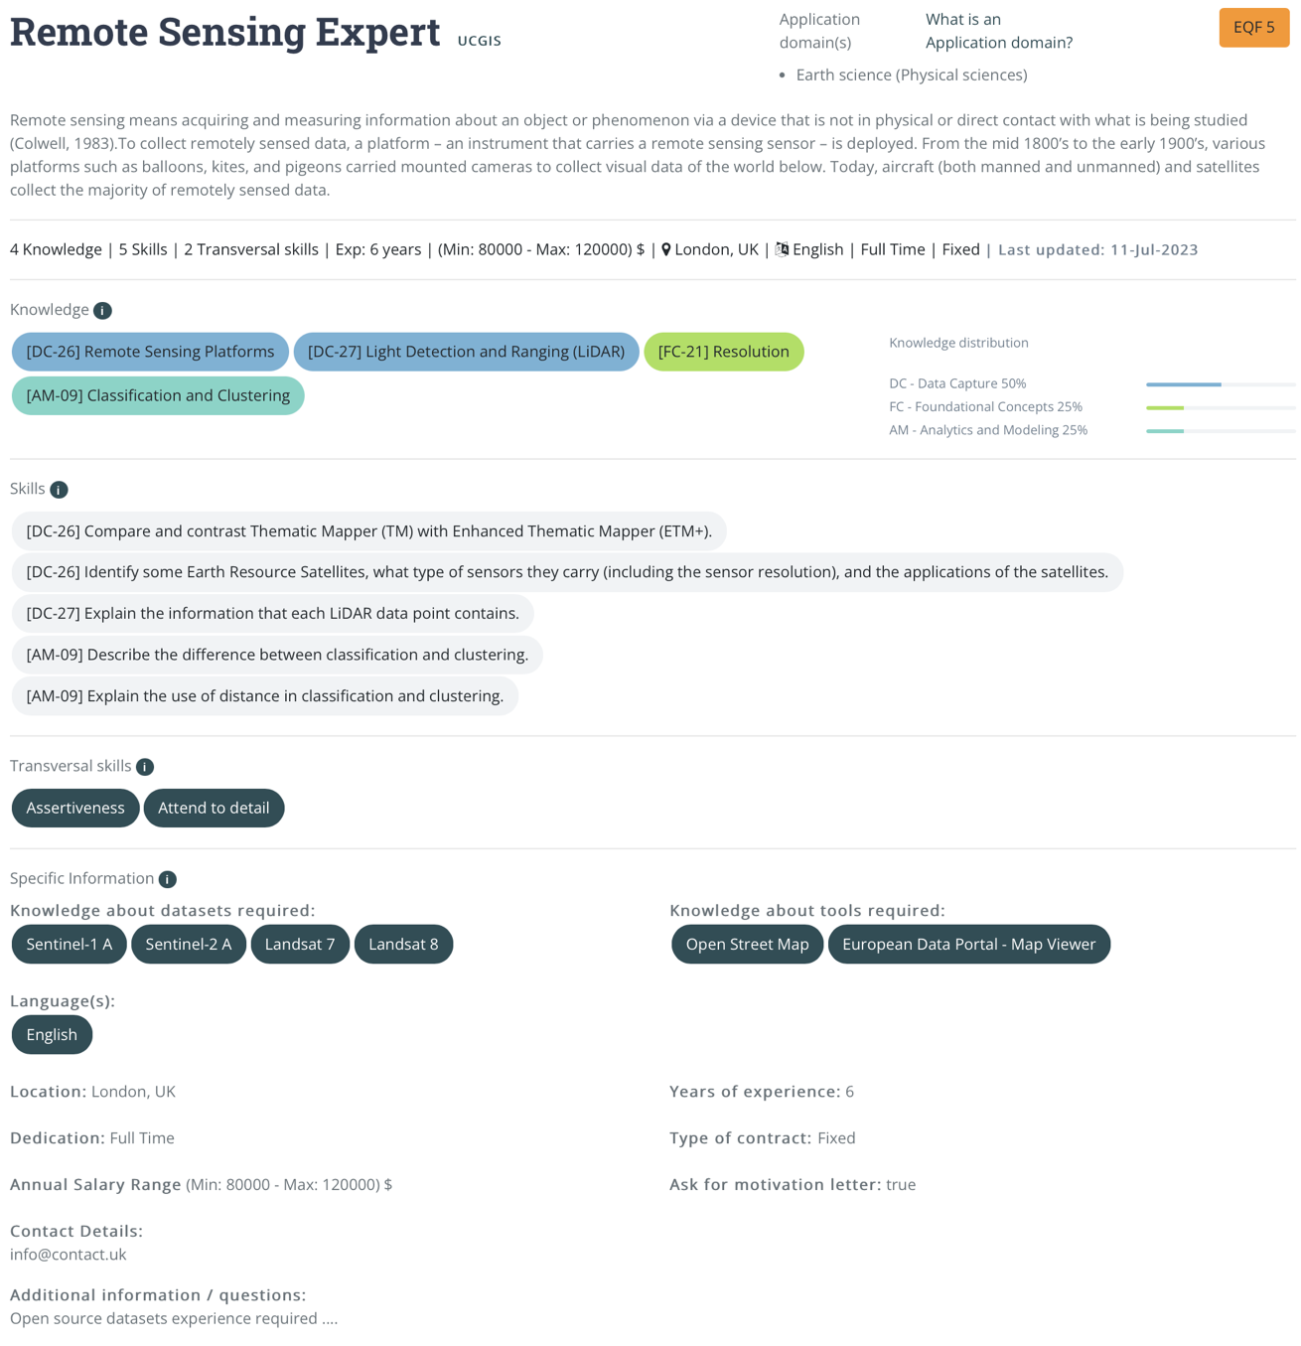

7

6

5

4

1

3

2

Figure 12. Job offer detail view

In the detailed view, the different fields of an occupational profile are shown: (1) description, (2) EQF level, (3) knowledge required (BoK annotations), (4) skills required (BoK annotations), (5) transversal skills required, and (6) a set of specific information required for a job offer, including datasets and tools which are required to perform the task, and other information such as the location of the offer, salary range, etc. The distribution of concepts from different areas of knowledge contained in the BoK is presented with progress bars (7).

## Create or Edit a Job offer

By clicking the ‘

New Job offer

’ button the user can fill in the information in the new job offer, when duplicating an existing JO this form gets prefilled with the current information.

To be able to save job offers the user should be member of at least one organization, as explained in the section User details and organizations. If the user does not belong to any organization, a message is displayed (Figure 13). Click on this message to go to the organization page and create a new one or join an already existing one to be able to continue.

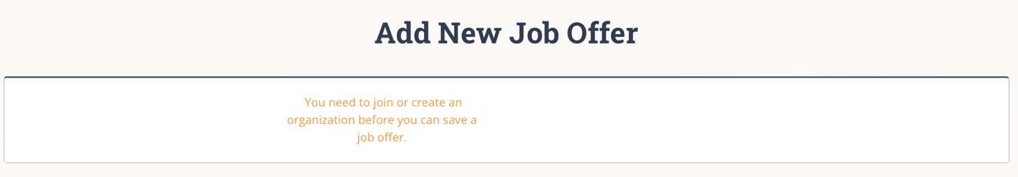

Figure 13. Warning if a user doesn’t belong to an organization

Once the user is member of an organization, the newly created job offer can be saved under that organization (1) (Figure 14), and all members of the same organization will be able to edit it. Division (2) is not compulsory, but can help keeping the content under big organizations organized.

The last dropdown allows

creating a new job offer based in existing occupational profile(s)

. To do so, select from the list of occupational profiles the one(s) you want to be the basis for your job offer, and it will automatically fill the fields with the data of the selected occupational profile(s). You can later complete the job offer with more information and edit it where needed.

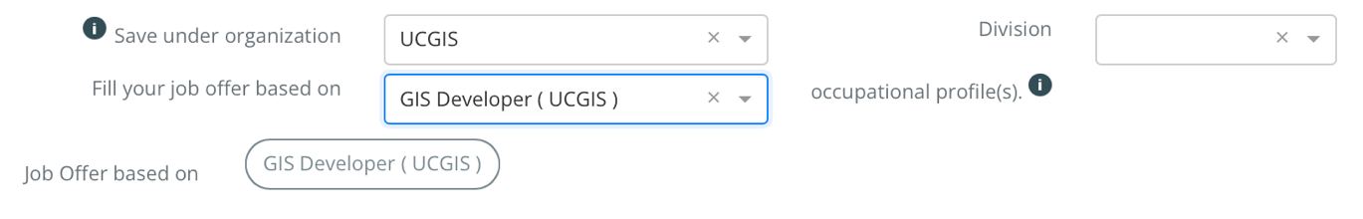

3

1

2

Figure 14. Saving a JO under an organization

To fill a job offer there are 4 main sections: General information (Figure 15), the Body of Knowledge browser to search for Knowledge and Skills (Figure 16), the knowledge and skills already added (Figure 17), transversal skills required (Figure 19) and Specific information (Figure 20).

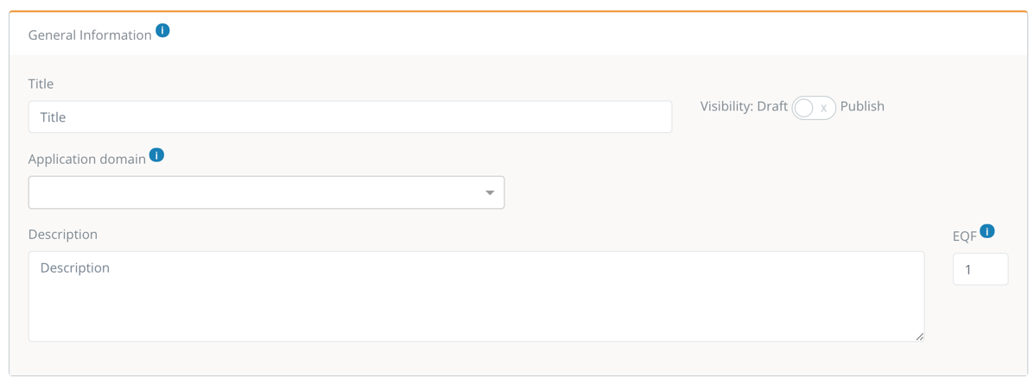

3

2

1

Figure 15. General information for a JO

Figure 15 contains the fields to introduce general information about a JO. ‘Title’ and ‘Description’ are free text fields. The ‘Application domain’ box (1) contains a list of the Fields of Education and Training by [UNESCO’s ISCED-F](https://ec.europa.eu/esco/portal/escopedia/International_Standard_Classification_of_Education_58__Fields_of_Education_and_Training_2013__40_ISCED-F_41_). Type to search by name of the Application domain and select the most suitable one(s). The EQF box (2) represents the EQF level required by this JO. Lastly, the visibility switch (3) can be selected to make the offer public. Note that draft (private) offers are also visible to members of the same organization where the offer is saved. under.

Next section of the JO is ‘Knowledge required’ (Figure 16). This section contains the Body of Knowledge interactive graphical and textual browser which is used to

add required knowledge

and to

add required skills

.

To

find BoK concepts

, there are two options: searching and browsing. To search, type your search term(s) in the search box (1) to filter BoK concepts containing the text either in the name or in the description; matching concepts are highlighted (2).

To

browse

, click on any part of the graphical BoK (2) and you will navigate through the concepts. Alternatively, you can also browse using the links in the textual view (3). Click on the ‘Details’ link to see the full information of a concept.

*Figure SEQ Figure \* ARABIC 9 Knowledge and skills view - Body of Knowledge*

Figure 16. Finding BoK concepts

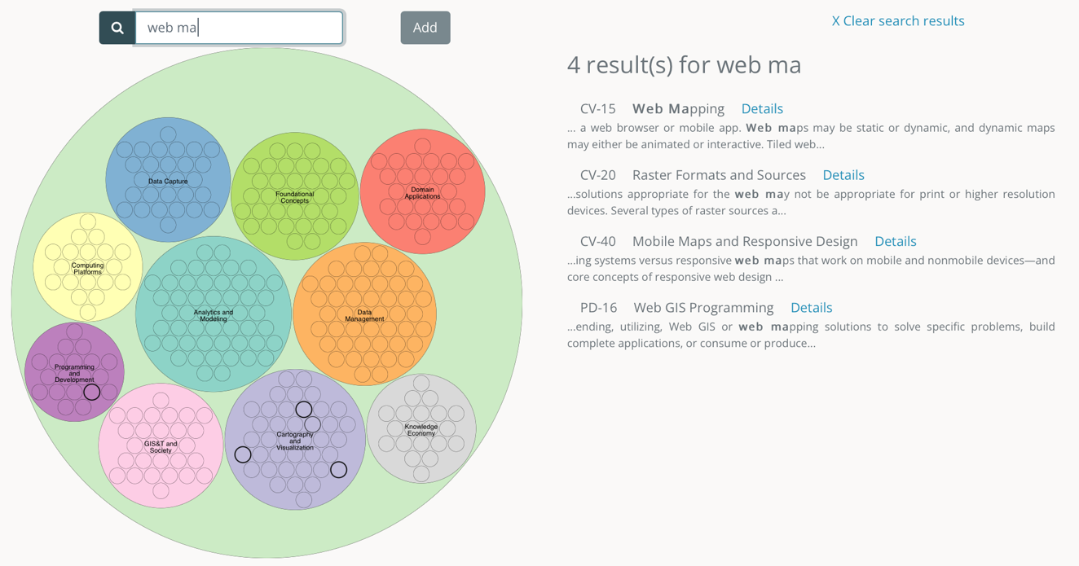

1

2

3

Once you find the concept you need as in Figure 17, to

*Figure SEQ Figure \* ARABIC 10 Selecting knowledge and skills as required*

add a concept selected and their related skills

, click the ‘Add’ button (1) and the concept selected (2) and their related skills (3) will be automatically added to ‘Knowledge required’ (4) and ‘Skills required’ (5) in a pill-shaped button in your JO (Figure 17). Each button contains a code between brackets (coming from the BoK) and its name. The knowledge pill buttons’ colour depends on the Knowledge area they belong to.

To

remove a knowledge or a skill

that was added previously, click on the ‘x’ symbol close to the knowledge or skill to be removed and the list will be updated accordingly. If you remove a ‘Knowledge required’ the system will ask you whether to delete or keep all its associated ‘Skills’.

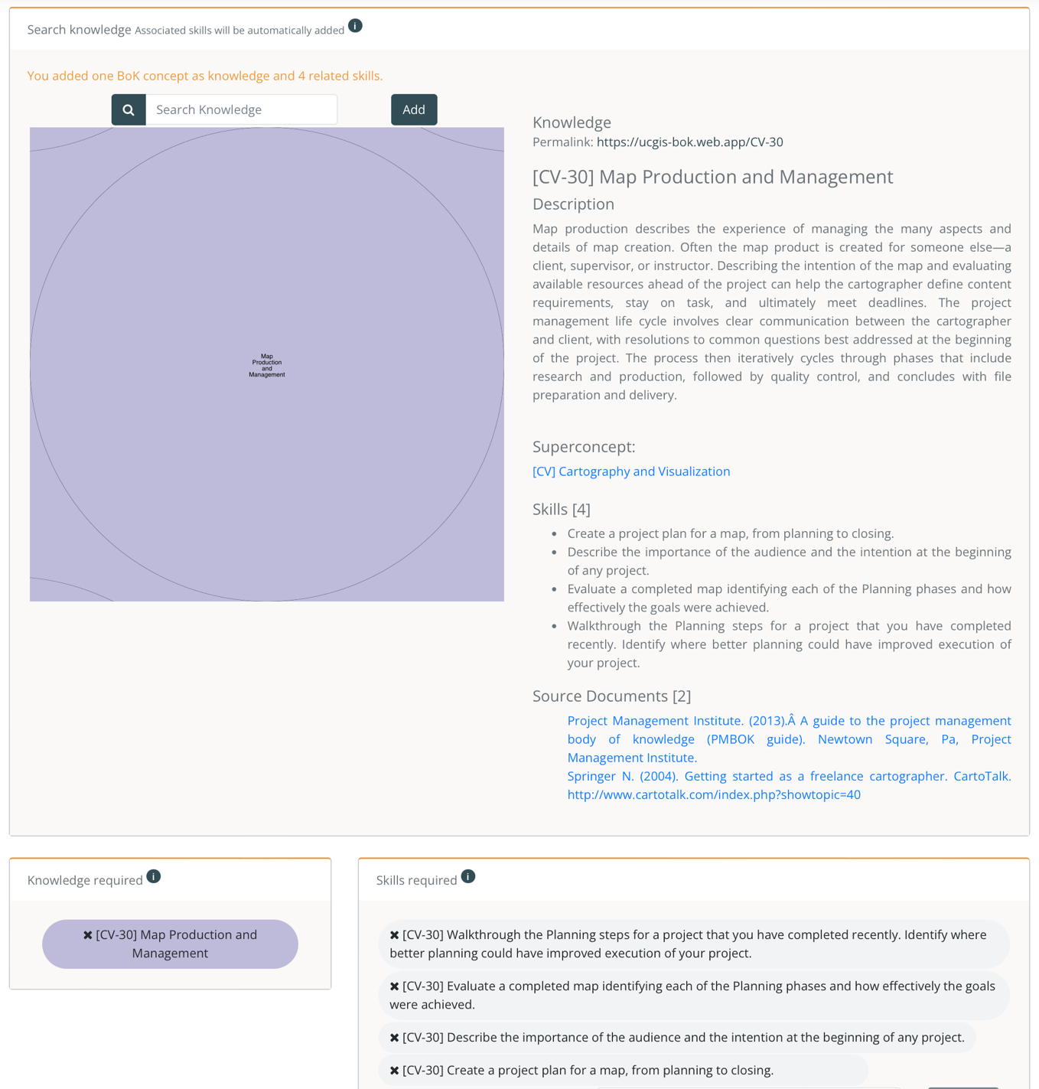

1

4

5

3

2

Figure 17. Adding knowledge and skills from the BoK

*Figure SEQ Figure \* ARABIC 8 JO General Information form*

2

You can

add a custom skill

by writing them in the text box (1) and then clicking on ‘Add Skill’ button (2). (Figure 18)

Figure 18. Add a custom skill to a JO

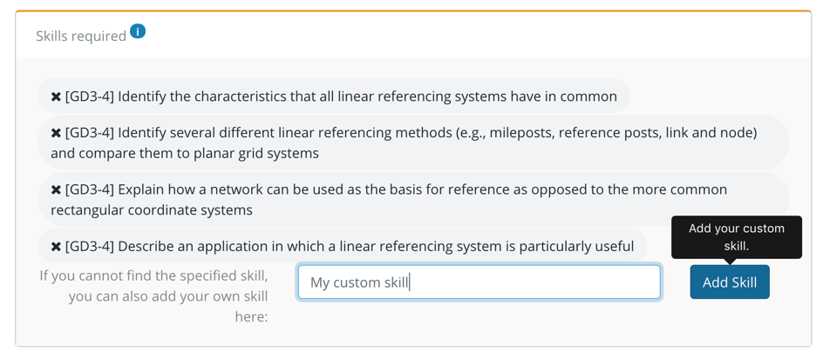

1

2

To

Figure 19. Transversal skills

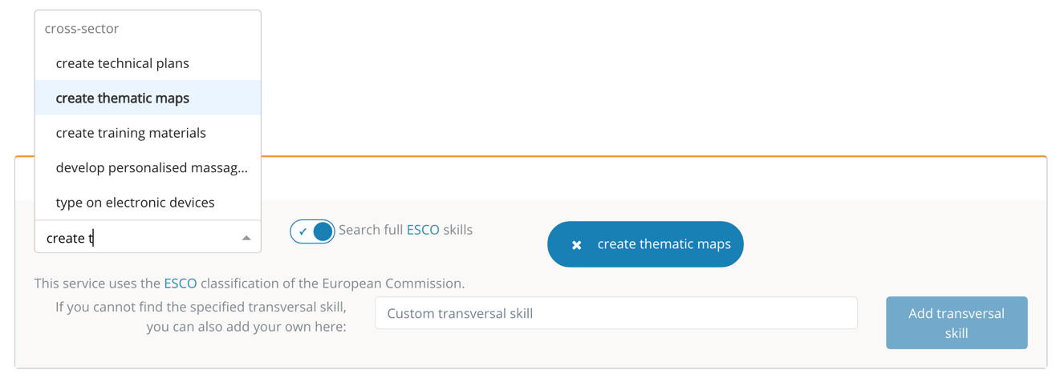

1

2

3

4

5

add transversal skills

(Figure 19) they should be selected from a closed list that contains a selection of skills from the ESCO classification (1). Typing in the text box filters in the list. Clicking on the switch (2) allows a full search on all ESCO skills. If a specific transversal skill is not found, this can be added as a custom skill, by typing it in custom skill text box (3) and then clicking the ‘Add transversal skill’ button (4). To remove a transversal skill, click the ‘x’ symbol and the list will be updated (5).

Specific information section contains information particularly related with job offers (Figure 20)

To

add Datasets required

they should be selected from a closed list that contains a Datasets included in [EO Handbook](http://database.eohandbook.com/data/dataactivity.aspx). Type in the field to start the search by text coincidence.

To

add Tools required

they should be selected from a closed list that contains merges the tools included in [INSPIRE](https://inspire-reference.jrc.ec.europa.eu/tools) and [ESA Open Source Resources](http://www.esa.int/Enabling_Support/Space_Engineering_Technology/Radio_Frequency_Systems/Open_Source_Software_Resources_for_Space_Downstream_Applications) that ranges from desktop/server software, libraries, plugins, online services or software resources for space downstream applications.

To

add languages

required select from the searchable dropdown list.

To remove items from any of these three lists, just click in the pill-shaped button you want to delete.

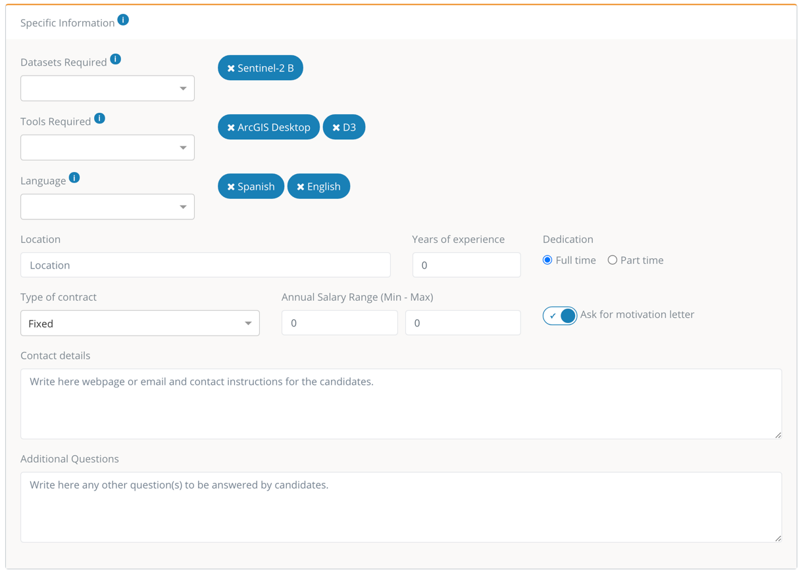

Figure 20. Specific information

To

add further job offer details

like location, Years of experience, Dedication, Annual salary range, and Additional questions, are free text fields. These fields are not mandatory, but a complete job offer is more attractive and can encourage people to apply.

To

add contact details

fill in the field with details for the candidate to contact the company.

A

request for a Motivation letter

could be (de)activated by enabling or disabling the switch.

To

add the type of contract

, select one of the options available when the list is displayed.

# Glossary of terms

**Application domain**. Term related to a specific area of study, following the ISCED-F classification

**ESCO.** Classification of European Skills, Competences, Qualifications and Occupations

**EQF.** The European Qualifications Framework for Lifelong Learning. The core of the EQF concerns eight reference levels describing what a learner knows, understands and is able to do, ranging from basic (Level 1) to advanced (Level 8)

<https://ec.europa.eu/ploteus/sites/eac-eqf/files/broch_en.pdf>

**ISCED-F**. International Standard Classification of Education: Fields of Education and Training 2013, maintained by UNESCO.

<https://ec.europa.eu/esco/portal/escopedia/International_Standard_Classification_of_Education_58__Fields_of_Education_and_Training_2013__40_ISCED-F_41_>

**Knowledge.** The body of facts, principles and theories and practices that is related to a field of work or study

**Skills**. Skills represent the ability to apply knowledge and use know-how to complete tasks and solve problems in a certain occupational profile.

**Transversal Skills** are those typically considered as not specifically related to a particular job, task, academic discipline or area of knowledge but as skills that can be used in a wide variety of situations and work settings. Based on ESCO transversal and cross-sector skills